Tips:
- Create small, manageable tasks.
- Dedicate time on a regular basis
- Delegate/ share the work with your MOA.
- Get in-practice support through PSP
- Share learnings with your fellow GPs

What’s involved?
The Panel Management Workbook
- It serves as a training manual to walk the clinic team through the steps involved in completing the phases of panel management
- It has fillable sections for the clinic team to use for standardized office protocols used for consistency, sustainability and training purposes
- Finally, it must be submitted to claim the Panel Development Incentive and/or Mainpro+ credits
Phase 1: Empanelment
Empanelment is the process of identifying all patients for which a physician is the Most Responsible Provider (MRP). Empaneled patients are those whom the patient and provider have each confirmed the patient-provider relationship (MRP). This relationship signifies that the physician is responsible for coordinating comprehensive care to each patient in their panel. Empanelment is the foundation for proactive, population-based health management.
Clearly defining the list of patients for which a physician or nurse practitioner (NP) is responsible is the starting point. The phase 1 portion of the work involves the following steps:
- Update your list of unassigned patients to ensure that all patients have someone listed as their primary provider.
- Set up a process to confirm MRP with patients along with updating their contact information.
- Define the STATUS options in your EMR- e.g. how are you defining “active”
- Update patient status in the demographics so that each patients’ status is accurate and up to date. (e.g. inactive patients not seen in 5 years)
- create and Implement a regular review process with your team so that you can maintain an accurate panel.
- Calculate you panel size and estimate your supply and demand.
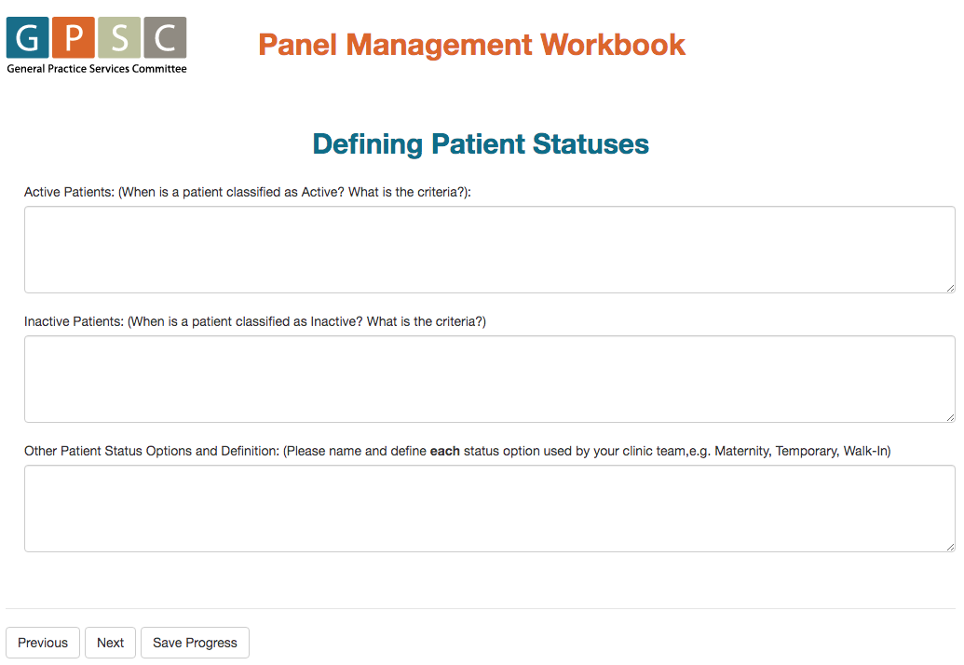
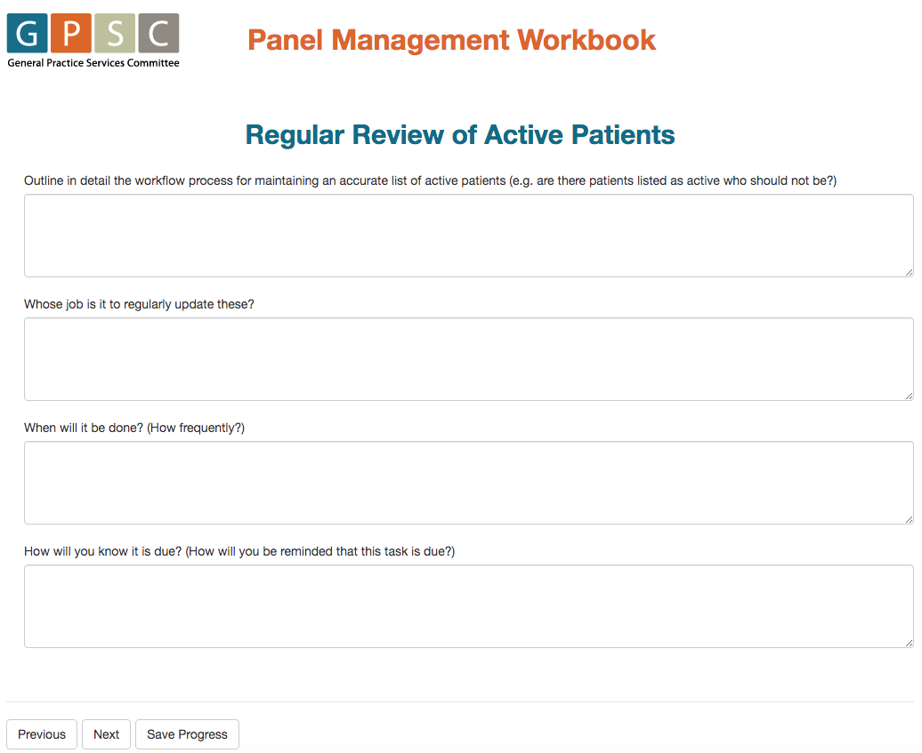
Phase 2: Panel Clean-up
The GPSC has defined panel clean-up as the process of creating accurate and up-to-date disease registries which act as the basis for proactive care planning and quality improvement activities. Registry reports improve understanding of patient populations and assists in identifying care gaps and opportunities.
The phase 2 of panel management involves the following steps:
- Choose 3-5 clinical conditions to start with
- Work with you team to decide how to consistently code those conditions in your EMR
- Use EMR tools to create a registry (list of patients with the same condition)
- Find patients not properly coded with those conditions and add the problem to the problem list/ disease registry.
- Create and implement a process for regular review of your registries to ensure that you maintain accurate disease registries.
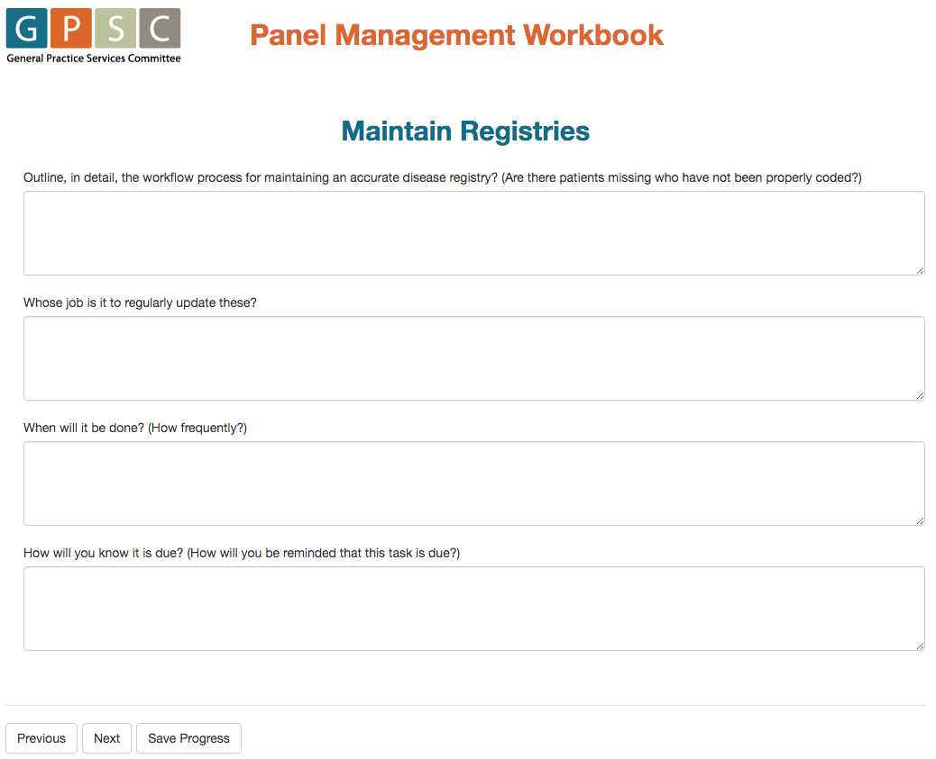
Phase 3: Panel Optimization
Panel Optimization is the implementation of pro-active care. It involves reviewing the active registries, identifying care gaps or opportunities for improvement, and implementing proactive care planning activities and recalls to improve care for patients in each registry.
This section will guide you through 5 Quality Improvement (QI) cycles for implementing proactive, registry based care.
- Clean-up an additional 7-10 registries
- Identify consistent coding protocols for those conditions
- Define a population to focus your pro-active care goal on
- Review that registry and identify who requires more consistent care
- Develop an AIM statement
- Define how you will know whether you’re successful (i.e. Measure!)
- Implement an improvement process
- Monitor your results
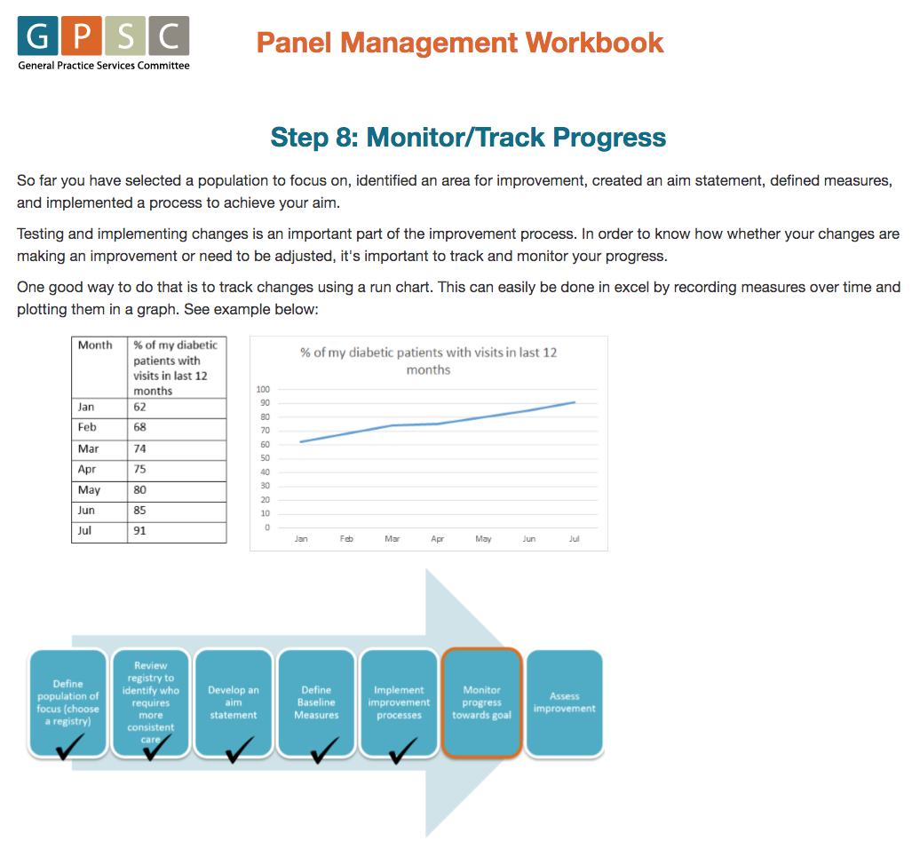
- Reflect and assess improvement.
